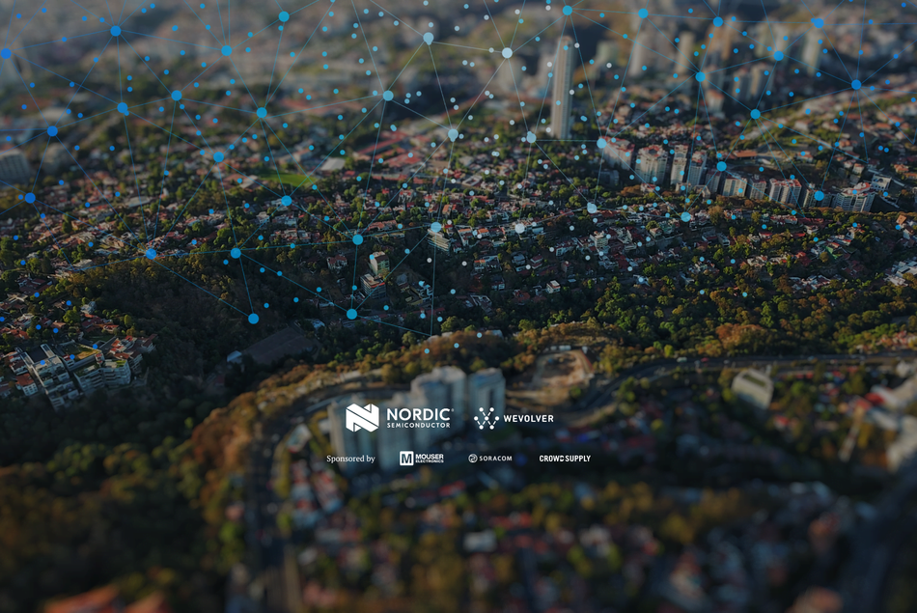

**Connect for Good: Low-Power Wireless Sustainability Challenge - Progress Update**

We invite engineers, entrepreneurs, inventors, and developers to submit a project that uses low-power wireless technology to solve issues related to the United Nations Sustainable Development Goals 7, 11, 13 & 15.

Project Name*

(Ensure this is the same as your first entry)

Name*

First Name Last Name

* **About You**

Email*

[example@example.com](mailto:example@example.com)

* **Your Project**

Explain the development of your project since receiving the nRF9160 DK. (in less than 500 words)*

Has your development stage changed since you received the nRF9160 DK? - If so, what is your current status?

Additional comments.

Please, supply images, renders, or technical drawings of your project's progress. (max 10)*

Support your submission's progress with video content. (optional, but a useful tool to get your idea across clearly.)

* **Terms & Conditions**
* I read and accept the [Terms & Conditions](https://wevlv.co/nordic-terms-conds). **\***
* his challenge is for original ideas only. Can you confirm that you own or have rights to the intellectual property of your submission? **\***
* By checking this box, you confirm that this your final progress update submission.
* By checking this box, you allow us to share your submission publicly, prior to the end of the challenge.
* Please, feel free to email us at challenges@wevolver.com if you need any further information.